IOT REPORT_1

TWO Basic approaches -

1. Make your own webpage,server and display the data
2. Use readily available services like Thingspeak,thinger.io,etc.

Webpage approach:-
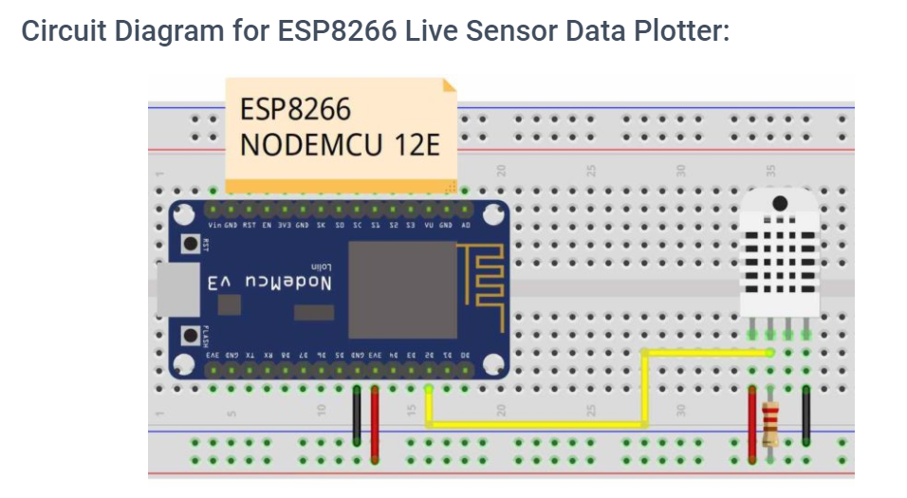
CODE:

#include <ESP8266WiFi.h>
#include <ESPAsyncWebServer.h>
#include "DHT.h"
#include <ESPAsyncTCP.h>

// Replace with your network credentials
const char* ssid = "Your_SSID";
const char* password = "Your_Password";

#define DHTPIN 4 // Digital pin 2 (GPIO 4) connected to the DHT sensor

// Uncomment the type of sensor in use:
//#define DHTTYPE DHT11 // DHT 11
#define DHTTYPE DHT22 // DHT 22 (AM2302)
//#define DHTTYPE DHT21 // DHT 21 (AM2301)

DHT dht(DHTPIN, DHTTYPE);

// current temperature & humidity, this will be updated in loop function
float t = 0.0;
float tf = 0.0;
float h = 0.0;

// Create AsyncWebServer object on port 80
AsyncWebServer server(80);

unsigned long previousMillis = 0; //stoe last time DHT was updated
const long interval = 1000; // Updates DHT readings every 1 seconds

//web page
const char index_html[] PROGMEM = R"webpage(
<!DOCTYPE HTML><html>
<head>
<meta name="viewport" content="width=device-width, initial-scale=1">
<script src="https://code.highcharts.com/8.0/highcharts.js"></script>
<style>
body {
min-width: 300px;
max-width: 800px;
height: 400px;
margin: 0 auto;
}
h2 {
font-family: Arial;
font-size: 2.5rem;
text-align: center;
}
</style>
</head>
<body>
<h2>ESP8266 Weather Station Chart</h2>
<div id="temperature-chart" class="container"></div>
<div id="fahrenheit-chart" class="container"></div>
<div id="humidity-chart" class="container"></div>
</body>
<script>
var chartT = new Highcharts.Chart({
chart:{ renderTo : 'temperature-chart' },
title: { text: 'Temperature in Degree Celsius' },
series: [{
showInLegend: false,
data: []
}],
plotOptions: {
line: { animation: false,
dataLabels: { enabled: true }
},
series: { color: '#059e8a' }
},
xAxis: { type: 'datetime',
dateTimeLabelFormats: { second: '%H:%M:%S' }
},
yAxis: {
title: { text: 'Temperature (Celsius)' }
},
credits: { enabled: false }
});
setInterval(function ( ) {
var xhttp = new XMLHttpRequest();
xhttp.onreadystatechange = function() {
if (this.readyState == 4 && this.status == 200) {
var x = (new Date()).getTime(),
y = parseFloat(this.responseText);
if(chartT.series[0].data.length > 50) {
chartT.series[0].addPoint([x, y], true, true, true);
} else {
chartT.series[0].addPoint([x, y], true, false, true);
}
}
};
xhttp.open("GET", "/temperature", true);
xhttp.send();
}, 1000 ) ;

var chartF = new Highcharts.Chart({
chart:{ renderTo:'fahrenheit-chart' },
title: { text: 'Temperature in Fahrenheit' },
series: [{
showInLegend: false,
data: []
}],
plotOptions: {
line: { animation: false,
dataLabels: { enabled: true }
}
},
xAxis: {
type: 'datetime',
dateTimeLabelFormats: { second: '%H:%M:%S' }
},
yAxis: {
title: { text: 'fahrenheit (F)' }
},
credits: { enabled: false }
});
setInterval(function ( ) {
var xhttp = new XMLHttpRequest();
xhttp.onreadystatechange = function() {
if (this.readyState == 4 && this.status == 200) {
var x = (new Date()).getTime(),
y = parseFloat(this.responseText);
//console.log(this.responseText);
if(chartF.series[0].data.length > 50) {
chartF.series[0].addPoint([x, y], true, true, true);
} else {
chartF.series[0].addPoint([x, y], true, false, true);
}
}
};
xhttp.open("GET", "/fahrenheit", true);
xhttp.send();
}, 1000 ) ;

var chartH = new Highcharts.Chart({
chart:{ renderTo:'humidity-chart' },
title: { text: 'Humidity (%)' },
series: [{
showInLegend: false,
data: []
}],
plotOptions: {
line: { animation: false,
dataLabels: { enabled: true }
},
series: { color: '#18009c' }
},
xAxis: {
type: 'datetime',
dateTimeLabelFormats: { second: '%H:%M:%S' }
},
yAxis: {
title: { text: 'Humidity (%)' }
},
credits: { enabled: false }
});
setInterval(function ( ) {
var xhttp = new XMLHttpRequest();
xhttp.onreadystatechange = function() {
if (this.readyState == 4 && this.status == 200) {
var x = (new Date()).getTime(),
y = parseFloat(this.responseText);
//console.log(this.responseText);
if(chartH.series[0].data.length > 50) {
chartH.series[0].addPoint([x, y], true, true, true);
} else {
chartH.series[0].addPoint([x, y], true, false, true);
}
}
};
xhttp.open("GET", "/humidity", true);
xhttp.send();
}, 1000 ) ;
</script>
</html>)webpage";

void setup(){
// Serial port for debugging purposes
Serial.begin(115200);

// Connect to Wi-Fi
WiFi.begin(ssid, password);
Serial.println("Connecting to WiFi");
while (WiFi.status() != WL_CONNECTED) {
delay(1000);
Serial.println(".");
}

// Print ESP32 Local IP Address
Serial.println(WiFi.localIP());

// Route for root / web page
server.on("/", HTTP_GET, [](AsyncWebServerRequest *request){
request->send_P(200, "text/html", index_html);
});
server.on("/temperature", HTTP_GET, [](AsyncWebServerRequest *request){
request->send_P(200, "text/plain", String(t).c_str());
});
server.on("/fahrenheit", HTTP_GET, [](AsyncWebServerRequest *request){
request->send_P(200, "text/plain", String(tf).c_str());
});
server.on("/humidity", HTTP_GET, [](AsyncWebServerRequest *request){
request->send_P(200, "text/plain", String(h).c_str());
});

// Start server
server.begin();
dht.begin();
}

void loop(){
unsigned long currentMillis = millis();
if (currentMillis - previousMillis >= interval) {
// save the last time you updated the DHT values
previousMillis = currentMillis;
// Read temperature as Celsius (the default)
float currentT = dht.readTemperature();

// if temperature read failed, we don't want to change t value
if (isnan(currentT)) {
Serial.println("Failed to read from DHT sensor!");
Serial.println(currentT);
}
else {
t = currentT;
Serial.println(t);
}
// Read temperature as Fahrenheit
float currentTf = dht.readTemperature(true);
// if temperature read failed, we don't want to change tf value
if (isnan(currentTf)) {
Serial.println("Failed to read from DHT sensor!");
}
else {
tf = currentTf;
Serial.println(tf);
}

// Read Humidity
float currentH = dht.readHumidity();
// if humidity read failed, we don't want to change h value
if (isnan(currentH)) {
Serial.println("Failed to read from DHT sensor!");
}
else {
h = currentH;
Serial.println(h);
}
}
}

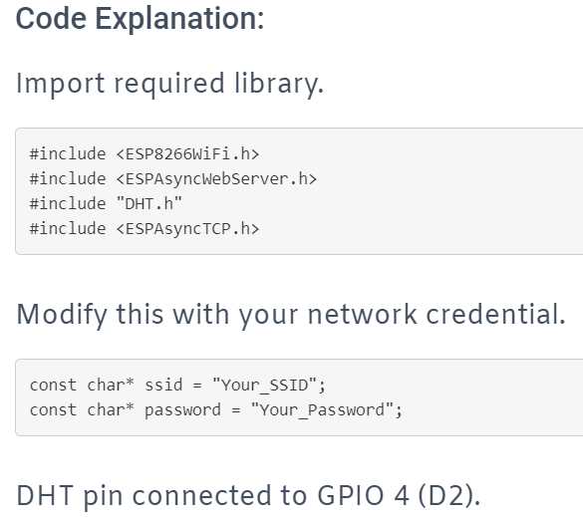

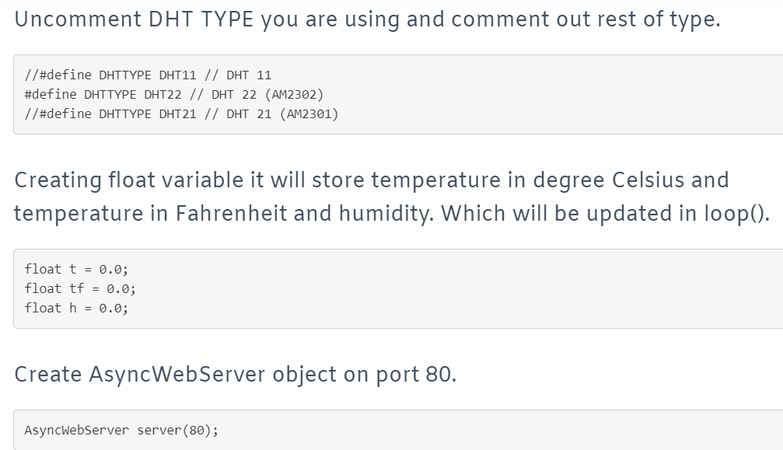

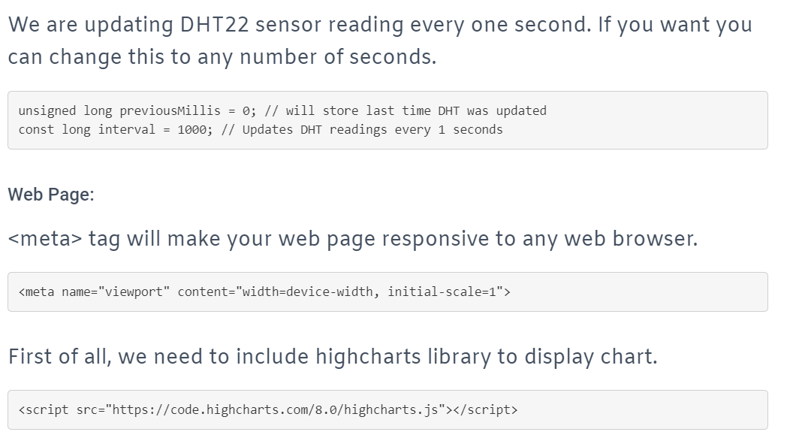
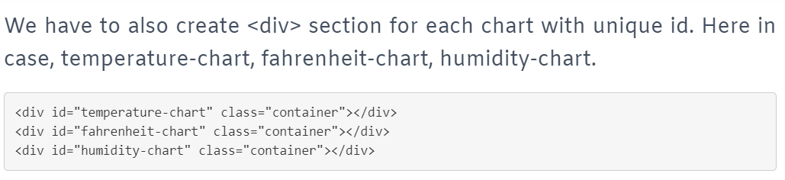

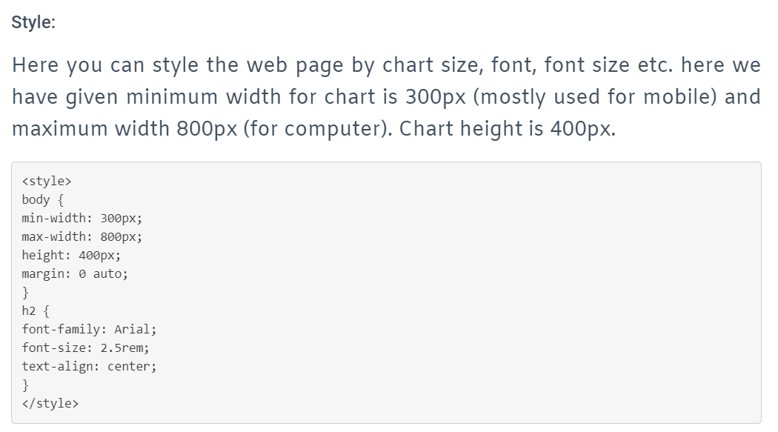
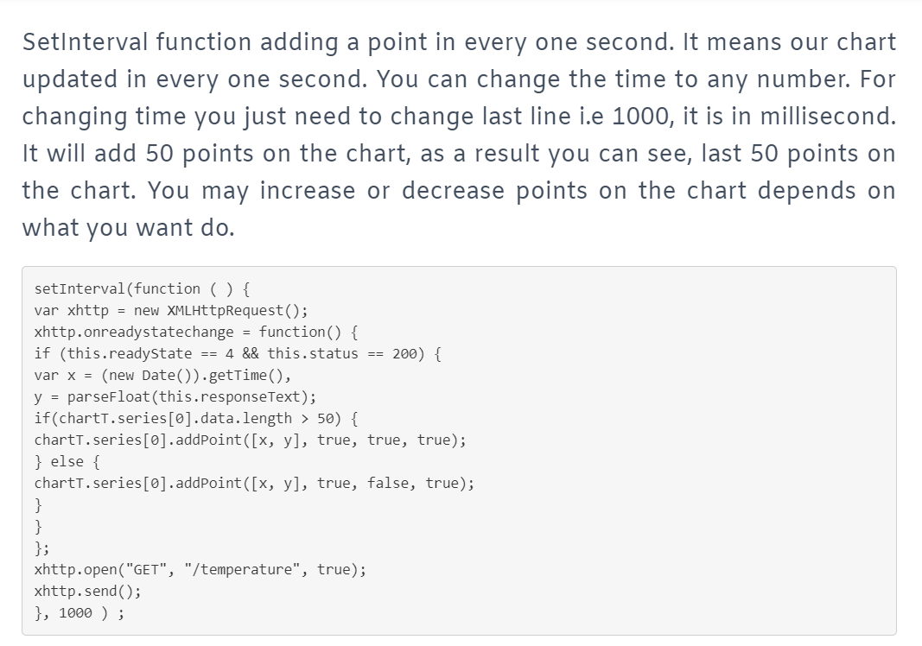
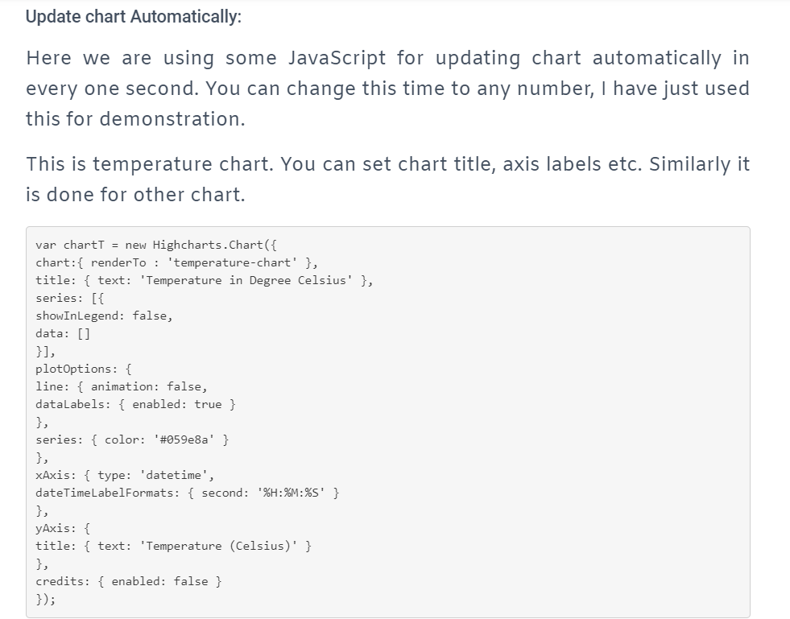
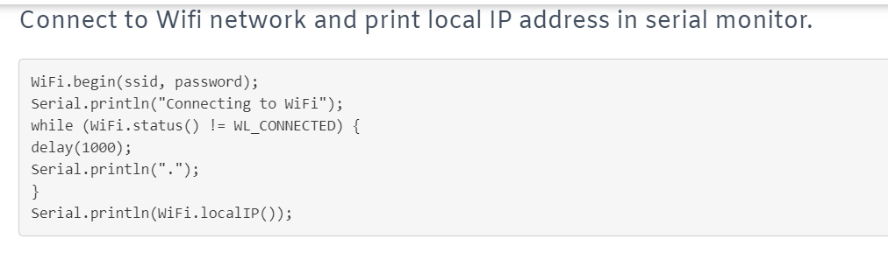

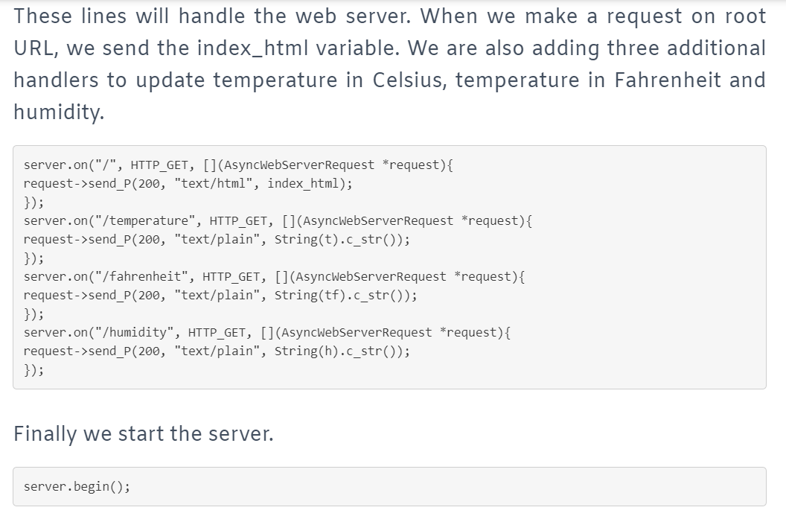

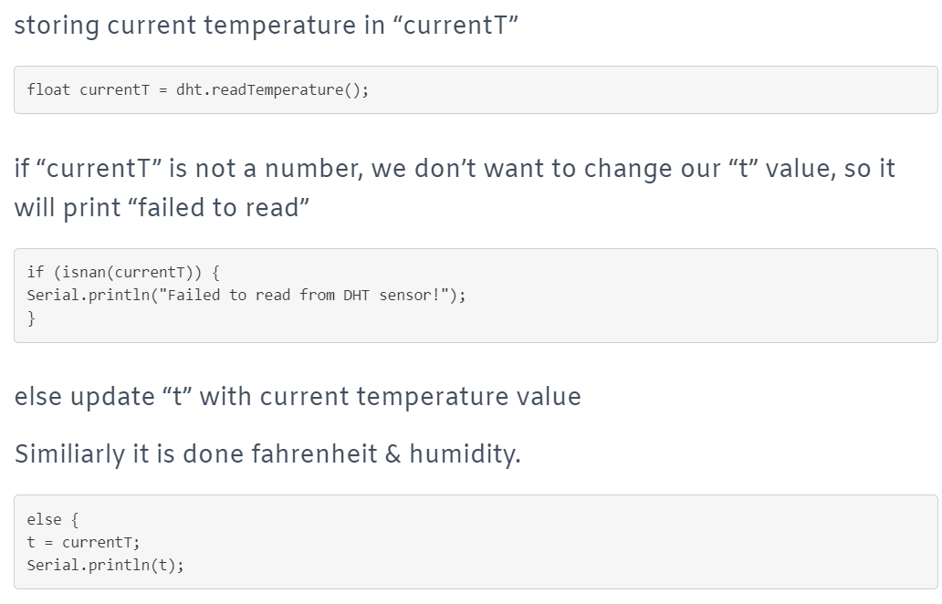
Refer to these links for this :-
https://youtu.be/Gfz2OBbtBP0

https://youtu.be/lEVoRJSsEa8
https://randomnerdtutorials.com/esp32-esp8266-plot-chart-web-server/

https://circuits4you.com/2019/01/11/esp8266-data-logging-with-real-time-graphs/

https://randomnerdtutorials.com/esp32-esp8266-plot-chart-web-server/

Thinger.io approach:-

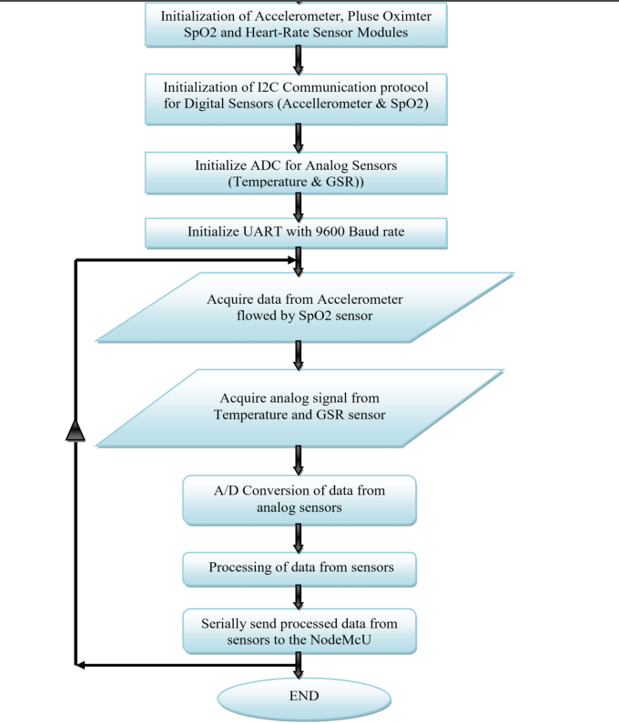

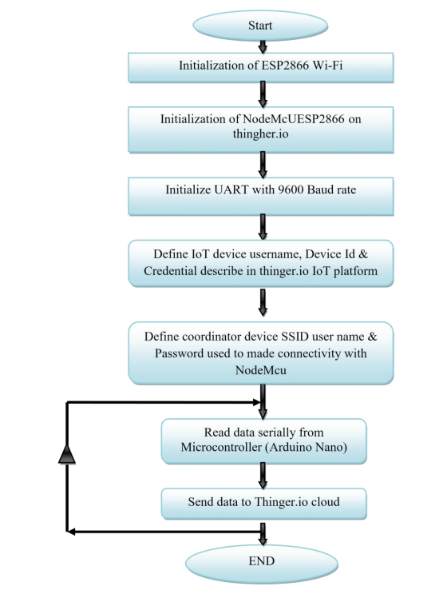

Program Flow chart for NodeMcU Wi-Fi Dev. board

The platform :-
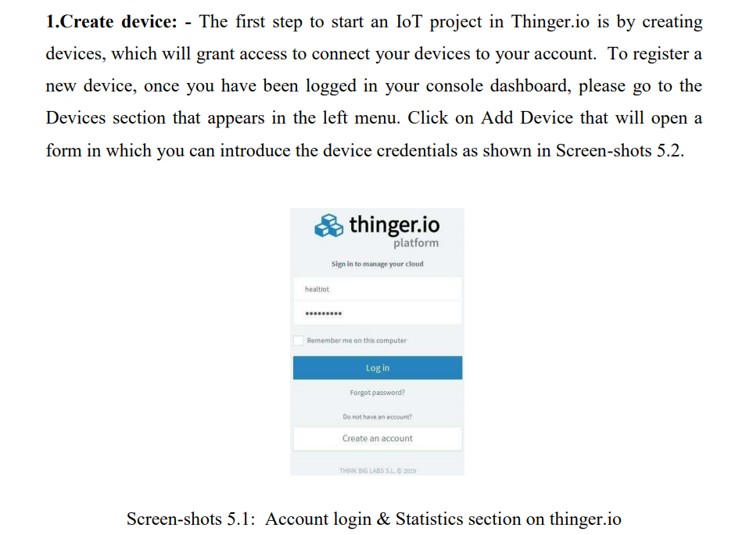

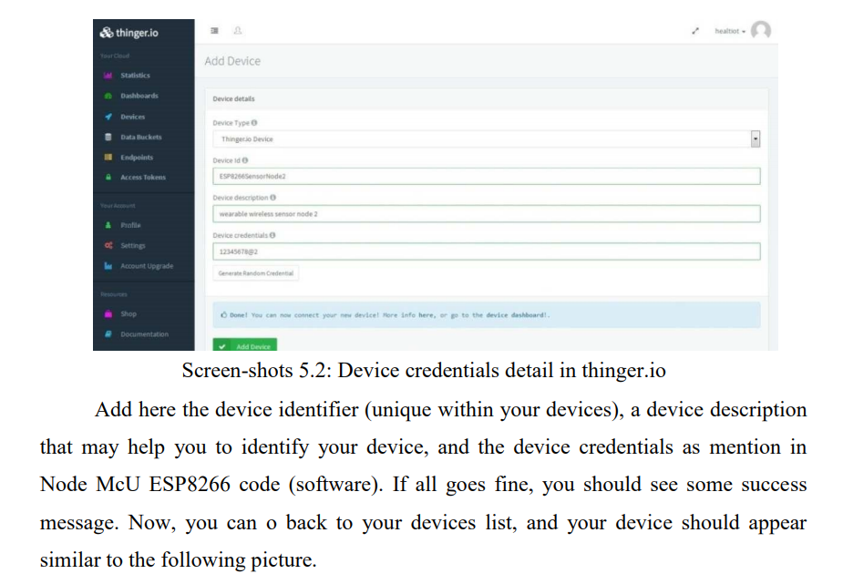
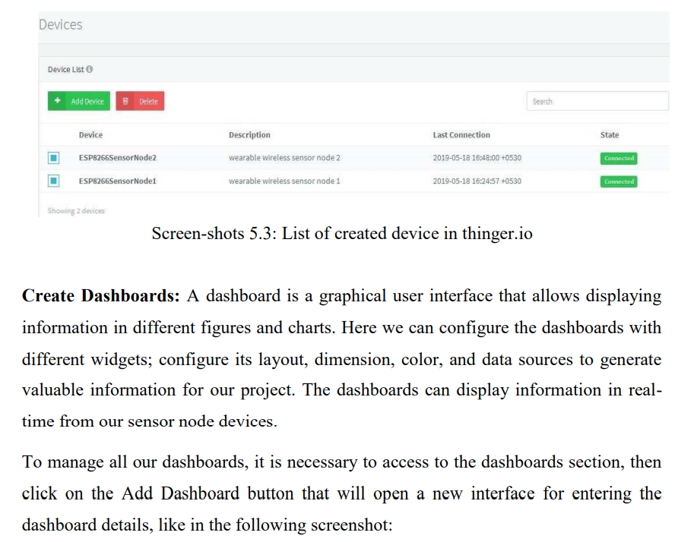
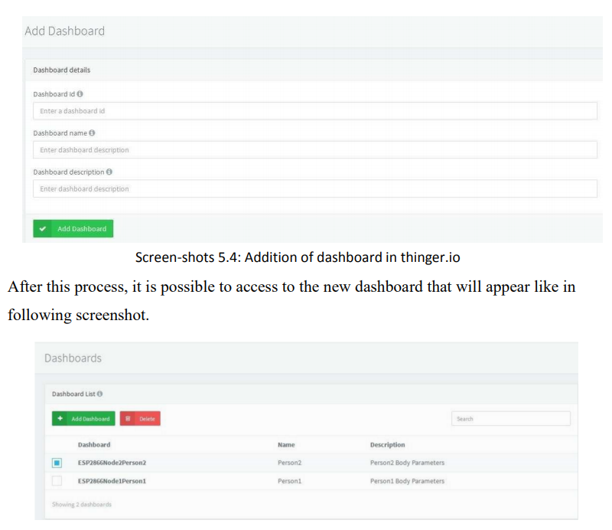

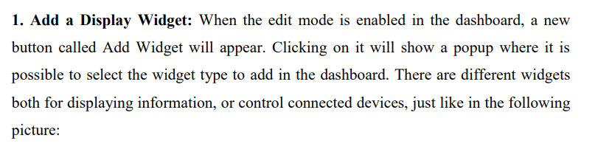

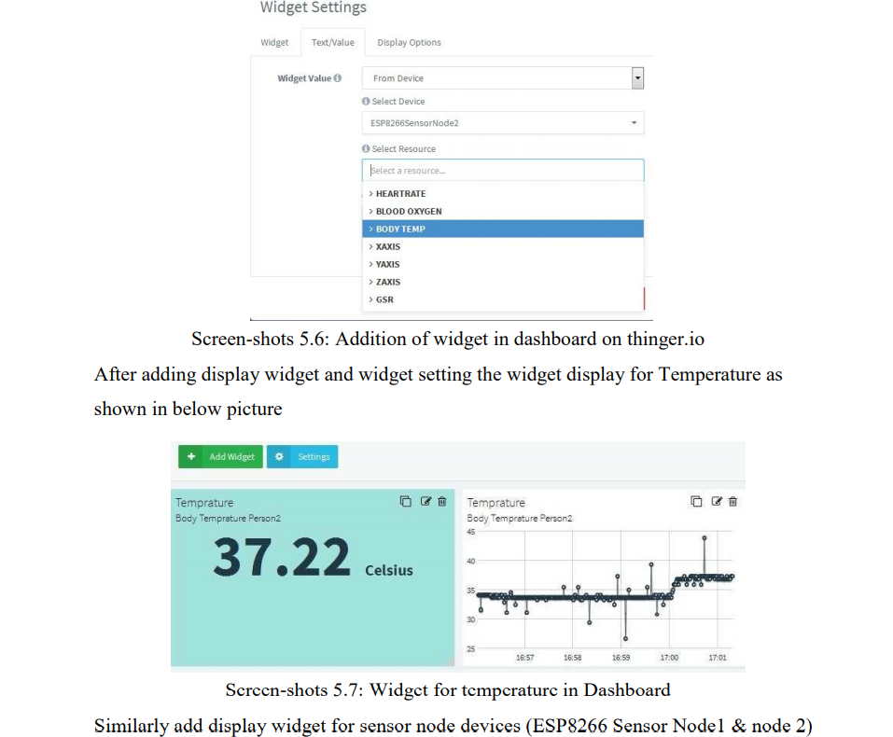
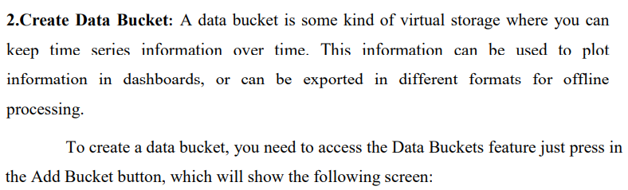
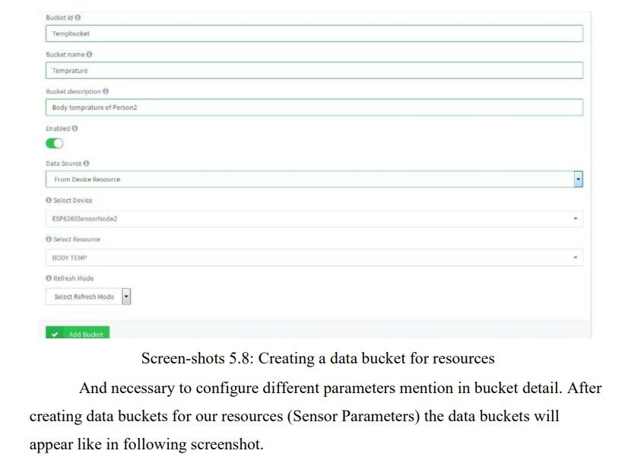
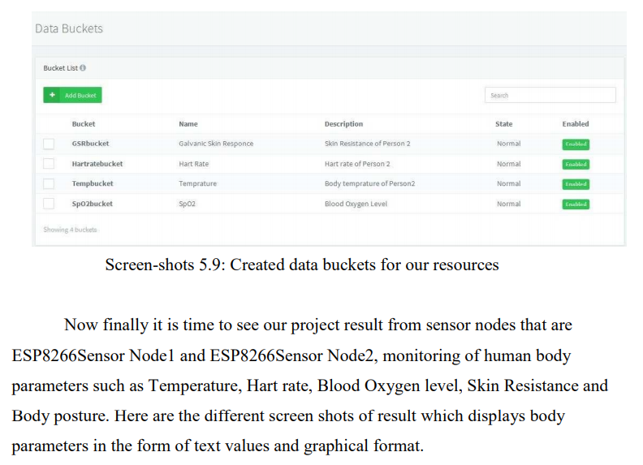
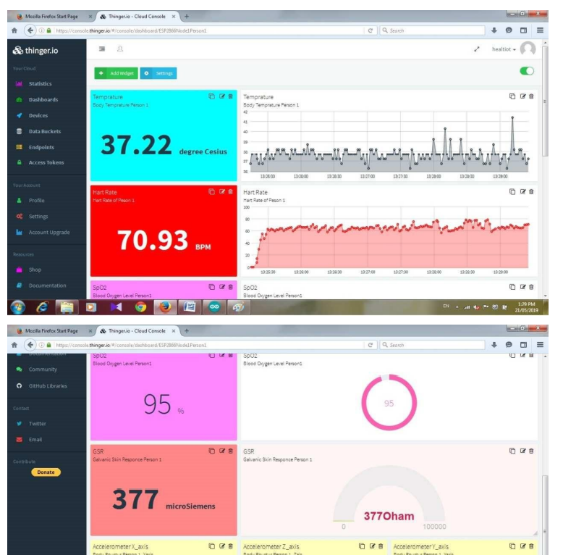

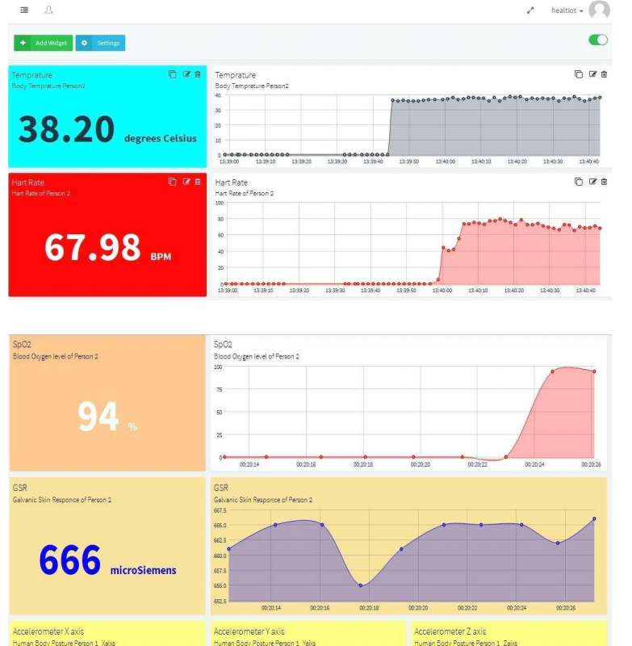

Can refer to this :- https://youtu.be/rvAM3BCiHJs

Use cases -

Medical science :
Patient monitoring undergoing physiotherapy and patient surveillance. As we need proper counselling for health. And this need can be satisfied, because the entire patient data is stored in one place which can be used for further recovery . So it provides medical help to patients as well as to the family members of patients.

Sports science :
• For analysis of sport rehabilitation exercises.
• Recognition of physical activities and their intensities
It is also applicable for player monitoring. Starting with the Football we are lacking in this day by day if we use our project for this then we easily monitor the player and according to that we increase the efficiency of player as well as game. By this we know how to kick the ball, how to scores goal and stop that (for opponent), means we know all the defensive criteria.
For Military :
Here we can also use this project for monitoring the soldier to know the day to day routine of them and the database can be used for the improvement of soldiers health therefore increase efficiency of nation‘s military.

And other :
• Human motion capture and analysis.
• For interactive dance performance.
• Human motion tracking for rehabilitation

BLYNK APPLICATION IN THE PROJECT

Through Blynk we can plot the graphical data which will be given by the sensors we will be using.
Blynk uses virtual pin concept through which we can push data from the nodemcu to the blynk mobile app widgets and also get the data from the widgets to the nodemcu via the ESP8266 wifi module present.Virtual Pin is a concept invented by Blynk Inc. to provide exchange of any data between hardware and Blynk mobile app.

Objective 1: To monitor patient parameters (pulse and temp).

Equipments needed: 1) NodeMCU 2) Blynk Mobile App

Operation/ Working:

- Open Blynk App on mobile and create an account.
- Create a New Project
- Select the working board ( here NODEMCU)
- Select the widget as per necessity (here it will be Superchart and Value Display widgets)
- Tap the widgets for editing its properties . We can use digital or analog or virtual pins as per requirement in the project.
- After uploading the sensors data in the NODEMCU from Arduino IDE we can monitor the patient parameters on the widgets on the smartphone at a remote distance.

The thing to understand here is every sensor connected to Nodemcu will send its data which we will store in a value and send it to the blynk app via the virtual pin (here say V1 for eg.)

Let us store the incoming data from the pulse sensor (for eg.) in a variable name : pulse_val

Blynk_Write(V1){
Blynk.VirtualWrite(pin,pulse_val);
}

Objective 2: To monitor location of staffs and assignment of daily tasks.

Equipments required: 1) NODEMCU 2) BlynkAPP
3)GSM Module: UBLOX NEO 6M Gps

Operation/Working:

- Connect the NODEMCU to the Ublox module .
- 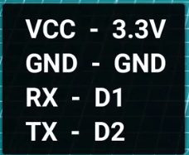 Connection in this mannner.
- Open Blynk app and select two ‘’labelled value’’ widgets (V1 and V2 connection resp) ,we can create more displays as per necessity.
- We will select the MAP widget from Blynk app (Pin-V0,satellite view or map view
- Upload the code to nodemcu and we will see the map updates on the blynk app.

CODE:

#include <TinyGPS++.h>
#include <SoftwareSerial.h>
#define BLYNK_PRINT Serial
#include <ESP8266WiFi.h>
#include <BlynkSimpleEsp8266.h>

static const int RXPin = 4, TXPin = 5; // GPIO 4=D2(conneect Tx of GPS) and GPIO 5=D1(Connect Rx of GPS
static const uint32_t GPSBaud = 9600; //If Baud rate 9600 didn't work in your case then use 4800 instead

TinyGPSPlus gps; // The TinyGPS++ object
WidgetMap myMap(V0); // V0 for virtual pin of Map Widget

SoftwareSerial ss(RXPin, TXPin); // The serial connection to the GPS device

BlynkTimer timer;

float spd; //Variable to store the speed
float sats; //Variable to store no. of satellites response
String bearing; //Variable to store orientation or direction of GPS

char auth[] = "--------------------"; //Project authentication key
char ssid[] = "-------"; // Name of your network (HotSpot or Router name)
char pass[] = "-------"; // Corresponding Password

//unsigned int move_index; // moving index, to be used later
unsigned int move_index = 1; // fixed location for now

void setup()
{
Serial.begin(115200);
Serial.println();
ss.begin(GPSBaud);
Blynk.begin(auth, ssid, pass);
timer.setInterval(5000L, checkGPS); // every 5s check if GPS is connected, only really needs to be done once
}

void checkGPS(){
if (gps.charsProcessed() < 10)
{
Serial.println(F("No GPS detected: check wiring."));
Blynk.virtualWrite(V4, "GPS ERROR"); // Value Display widget on V4 if GPS not detected
}
}

void loop()
{
while (ss.available() > 0)
{
// sketch displays information every time a new sentence is correctly encoded.
if (gps.encode(ss.read()))
displayInfo();
}
Blynk.run();
timer.run();
}

void displayInfo()
{
if (gps.location.isValid() )
{
float latitude = (gps.location.lat()); //Storing the Lat. and Lon.
float longitude = (gps.location.lng());

Serial.print("LAT: ");
Serial.println(latitude, 6); // float to x decimal places
Serial.print("LONG: ");
Serial.println(longitude, 6);
Blynk.virtualWrite(V1, String(latitude, 6));
Blynk.virtualWrite(V2, String(longitude, 6));
myMap.location(move_index, latitude, longitude, "GPS_Location");
spd = gps.speed.kmph(); //get speed
Blynk.virtualWrite(V3, spd);

sats = gps.satellites.value(); //get number of satellites
Blynk.virtualWrite(V4, sats);

bearing = TinyGPSPlus::cardinal(gps.course.value()); // get the direction
Blynk.virtualWrite(V5, bearing);
}

Serial.println();
}

Utility of this obejctive:
- Can monitor the location of individual staffs and give us a suitable planning procedure for the daily tasks of the individual.
- REST WORK in progresss………………………………….!!
- Working on IFTTT applet services integration to trigger certain actions for certain circumstances remotely which would make the project more handy and efficient.

*……………………………………….*

